FORM 12: Оклейка прислать строго до 15 апреля

DESCRIPTION | SAMPLE
Printing PP on wall partition:  Full size: 100cmL x 260cmH  Artwork size: 95cmL x 245cmH | 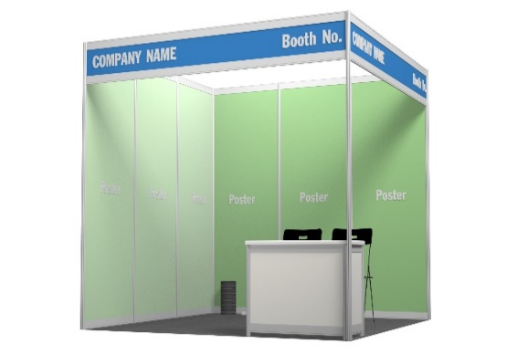 | 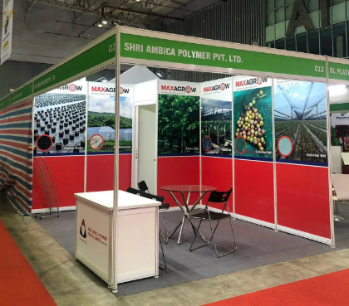
Printing Hiflex on wall partition:  Full size: 300cmL x 260cmH  Artwork size: 291cmL x 259cmH | 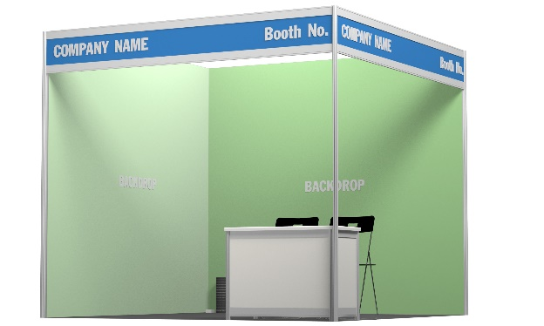 | 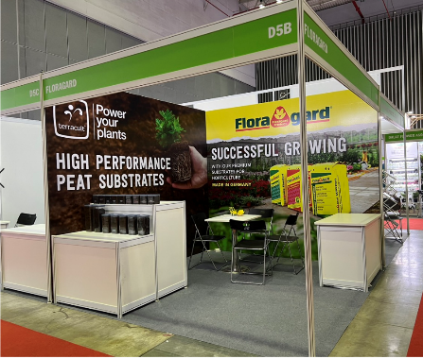
Printing PP on fascia name board:  Full size: 300cmL x 25cmH  Artwork size: 295cmL x 25cmH | 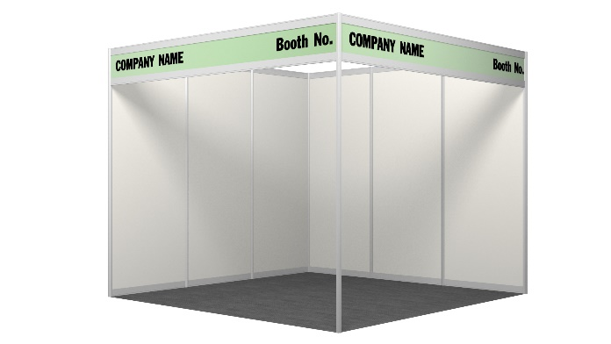 | 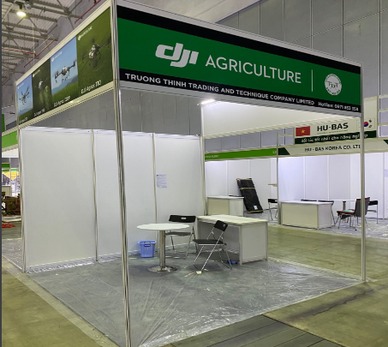
Printing PP on information counter:  Front: 97cmL x 64cmH  Side: 46cmL x 64cmH | 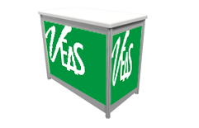 | 