Item | Description | Unit Price USD | Quantity | Total USD
Additional stand construction
TE01 | Carpet, needle punch  (grey / blue / red) | 10,00
TE02 | Carpet, rips quality  (grey / blue / red) | 11,00
TE03 | Carpet, velour quality  (grey / blue / red) | 54,00
WA01 | Wall panel, 96 x 247 cm,  -fitting the ordered stand package- | 34,00
WA03 | Wall panel, 50 x 250 cm,  -fitting the ordered stand package- | 21,00
TU01 | Lockable swing-door element, white  (door: 95x 200 cm)  -fitting the ordered stand package- | 87,00
TU02 | Lockable folding door element, white  (door: 95x200cm) | 87,00

Hall: |  | Booth No.: |  | Signature:
Additional furniture

TS50 | Table showcase, upper part glazed  100x 50x 100 cm |  |  |  | 156,00
HV2D | Showcase, tall with 2 built-in downlights  100x 50x 200 cm |  |  |  | 216,00
SC03 | Showcase, tall, fully glazed with 5 glass layers and jewellery downlights  50x 50x 200/250 cm |  |  |  | 252,00
DC50 | Display cube (max. 20 kg)  50x 50x 50 cm |  |  |  | 42,00
DC70 | Display cube (max. 20 kg)  50x 50x 70 cm |  |  |  | 51,00
DC100 | Display cube (max. 20 kg)  50x 50x 100 cm |  |  |  | 60,00
DC150 | Display cube (max. 20 kg)  100x 50x 100 cm |  |  |  | 72,00
REG1 | Flat shelf, white  100x 30 cm |  |  |  | 26,00
RES1 | Slope shelf, white  100x 30 cm |  |  |  | 26,00
RE4F | Shelf rack, with 5 shelves  100x 50x 250 cm |  |  |  | 102,00
LITF | Freestanding literature rack for A4 brochures |  |  |  | 30,00
SIDL | Cupboard, lockable, white  100x 45x 75 cm |  |  |  | 74,00
IC50 | Information counter, white, rectangular  100x 50 x 100 cm |  |  |  | 96,00
IC02 | Information counter, white, quarter rounded  r= 50 cm |  |  |  | 72,00
IC03 | Information counter, white, semi rounded  r= 100 cm |  |  |  | 96,00
TI80 | Table, square, white  80x 80x75 cm |  |  |  | 64,00
TU12 | Table, round, wooden table top  Ø 70cm x 70 cm ht |  |  |  | 63,00
TU15 | Bistro table, round, wooden table top  Ø 60cm x 1,15 cm ht |  |  |  | 65,00
TR80 | Coffee Table, round, glass table top  Ø 50 cm, 45 cm ht |  |  |  | 63,00
STST | Standard chair, black leather (same as package) |  |  |  | 39,00
BH70 | Bar stool (white) |  |  |  | 48,00
PAP1 | Waste paper basket |  |  |  | 8,00
DISP | Water dispenser incl. 2 bottles of 19l water |  |  |  | 168,00
FL19 | Additional bottle for water dispenser, 19l |  |  |  | 12,00
TO80 | Potted plant, 80 cm ht |  |  |  | 24,00
TO15 | Potted plant, 150 cm ht |  |  |  | 29,00
BL20 | Table Flowers, Ø 20 cm |  |  |  | 42,00
Hall: |  |  | Booth No.: |  |  | Signature:
KU80 | Kitchen sink unit with cupboard (without water supply)  100x 50x 85 cm |  |  |  | 96,00
FRID | Refrigerator,120l, including a 24-h socket |  |  |  | 228,00
Graphic services the artwork has to be delivered by the client
 | Graphic digital print, per m² |  |  |  | 27,00
 | Graphic print self-adhesive foil cut |  |  |  | 24,00
DLOG | Company logo digital print, 20x 20 cm |  |  |  | 42,00
 | Poster mounting on foamboard A0 |  |  |  | 60,00

Technical equipment
BI32 | 32” plasma screen incl. wall mounted rack | 588,00
BI42 | 42” plasma screen | 780,00
DVD | DVD-player | 141,00
FRRA | Freestanding rack for plasma screen | 84,00
Lighting equipment
SPO1 | Spotlight (the same like in the packages), 100 W | 48,00
SPL1 | Longarm spotlight, 100 W | 54,00
FLUT | Fluorescent tube, 40 W, 120cm | 35,00
HQIR | HQI lamp, 70 W, rectangular | 120,00
Services
STAR | Stand cleaning, during the fair,per m² | 9,00
 | Graphic fitter, per hour | On request
 | Carpenter, per hour | On request
 | Unskilled labour | On request
The price for the human power is charged on site depending on the real demand
Power equipment
ST50 | Socket, 500 W | 68,00
ST02 | Socket, 2000 W | On request

Product Pictures - Abridgement

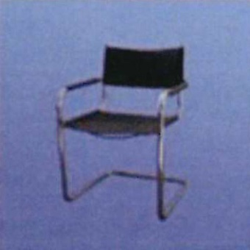  STST  Standard leather chair, black | 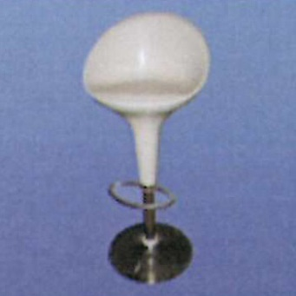  BH70  Bar stool, white | 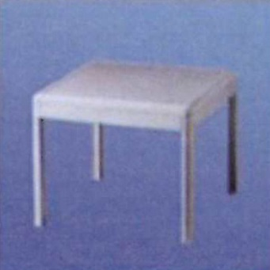  TI12  Table, square, white |  | 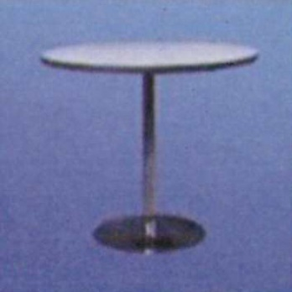  TR80  Table, round, white
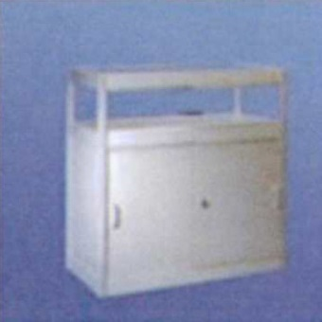  TS50  Table showcase, upper part glazed | 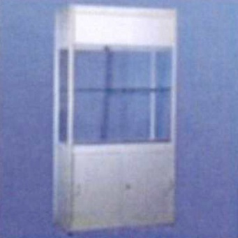  HV2D  Showcase, tall, with 2 built-in downlights | 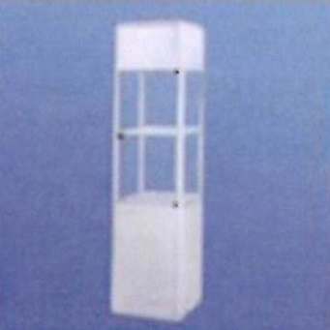  SC03  Showcase, tall fully glazed |  | 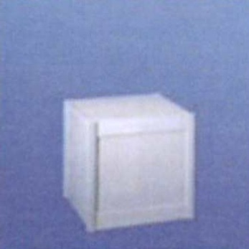  DC50  Display cube 50x 50x 50
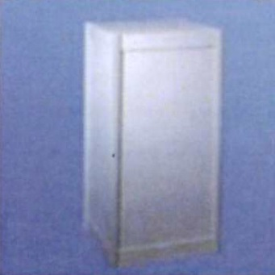  DC100  Display Cube 50x50x100 | 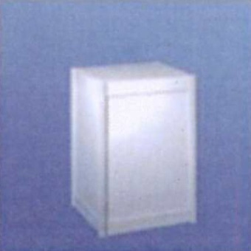  DC70  Display cube 50x50x70 | 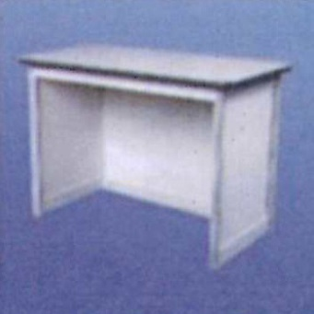  IC50  Information counter, white,Rectangular, 100x50x100 |  | 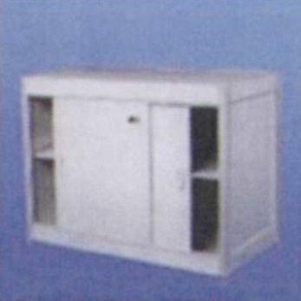  SIDL  Lockable cupboard
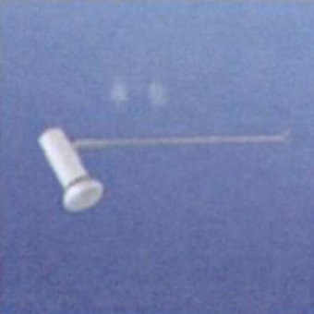
SPL1
Longarm spotlight
100 W

